**REQUIREMENT TRACEABILITY**

Requirement traceability helps us do the impact analysis,

Shows us a change that’s done in one requirement can affect another requirement

In order to keep track of this relationship create requirement traceability.

Click on the requirement

Go to requirement module

Click on Add Requirement Traceability

And select the requirements that affects your requirement or can be affected by your requirement

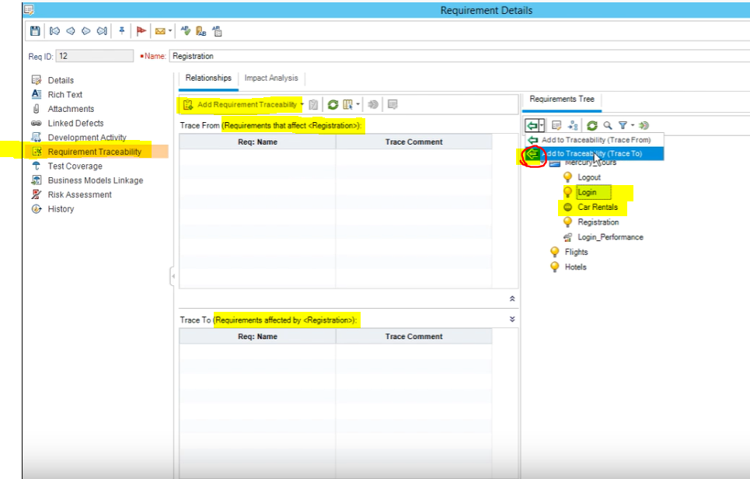

In this example, our requirement is Registration and we are going to examine how to add traceability for Log-in and Car Rentals.

**Do login and car rental requirements affect Registration?**

**Answer: No**

**are login and car rental requirements affected by Registration?**

**Answer: Yes, because without registering you can not login or rent a car.**

**So, we will add traceability (TRACE TO) for Login and Car Rental**

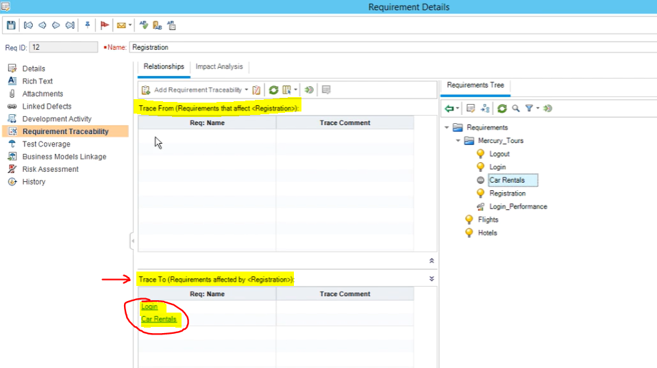

**IMPACT ANALYSIS**

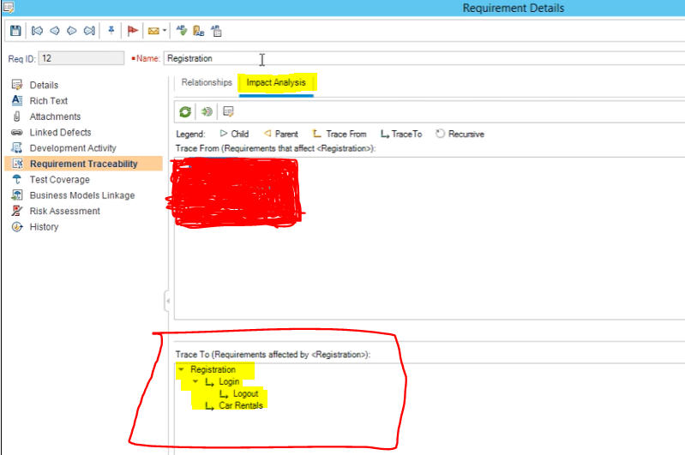



**Registration trace to Login and car rentals**

**Also Login trace to logout (in order to log out you need to login)**

**This way we know a change we make in registration may affect other related requirements.**

**Extra information**

**In order to do impact analysis, we need to understand the relation between the requirements**

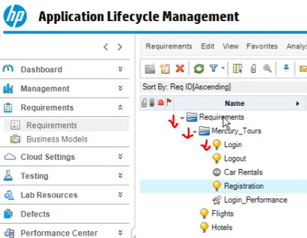

**Requirements is parent of Mercury Tours**

**Mercury Tours is parent of Login and Car Rentals**

**Now Let’s see our impact analysis**

